DONAHUE
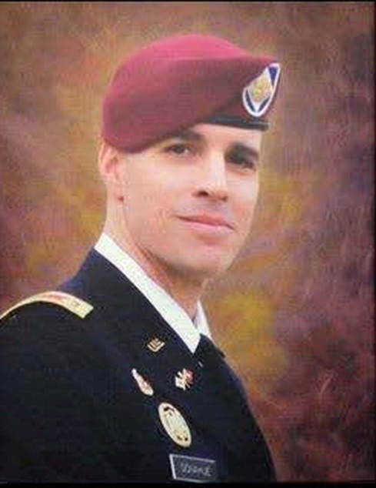
Michael enlisted in the Army as a Military Police Officer in 1995 serving at the 447th Military Police Company, Columbus, Ohio. From there he was stationed in Kentucky, South Korea and Fort Benning, Georgia. In April of 2000, Donahue graduated from the United States Army Officer Candidate School receiving his commission as a Signal Corps 2nd Lieutenant.
He attended the Signal Officer Basic Course at Fort Gordon, Georgia and in October 2000 was assigned to C Co, 82nd Signal Battalion, Fort Bragg, North Carolina as a Mobile Subscriber Equipment (MSE) Platoon Leader for 18 months. Michael then entered the U.S. Army Degree Completion Program in March 2002 and graduated Magna Cum Laude from Campbell University in July 2003. In May 2004, after completing the Signal Captains Career Course, he was assigned to the 82nd Airborne Division as the Battalion Signal Officer for 2nd Battalion, 504th Parachute Infantry Regiment. In March of 2005, Michael deployed with Task Force Devil to Eastern Afghanistan in support of Operation Enduring Freedom.
In April 2006, Michael took command of C Company, 1BSTB (1BCT, 82nd Airborne Division) where, in June 2007, he led his company with Task Force Devil to Iraq in support of Operation Iraqi Freedom. During that time, Donahue was responsible for a Combat Outpost conducting Full Spectrum Operations with two Route Security Platoons and one Quick Reaction Platoon. In addition to managing the planning and integration of intelligence, surveillance, and reconnaissance assets; as well as attack aviation, demolitions, counter-surveillance, and 120mm and 60mm mortar fire support, his mission also focused on Counter Insurgency operations along 80 miles of Main Supply Route and Civil-Military Operation amongst 8 Iraqi tribes and within 14 local villages.
On September 16th, 2014, Michael was serving as an operations support officer with C Company, HHB, XVIII Airborne Corps when he died after sustaining wounds when his convoy was attacked by a suicide bomber outside of a coalition base in Kabul, Afghanistan. The attack also wounded 13 civilians and killed another fellow US Soldier and one Polish Soldier.
“Mike was just an amazing officer and an amazing man in every way — spiritually, physically, and intellectually,” his friend Bob Foy said. “He was always positive, always there for the students. He had a huge impact on the students in the program.”
Michael was also a devoted runner, participating in the trail runners’ club that runs the Liberty Mountain trails each Wednesday.
Michael is buried at the Arlington National Cemetery in Arlington, Virginia.

