Chapter newsletter volume 2 – August 2019

Contents
From the Chapter President (Chair) Tim Wall bio here 2
Newly elected chapter officials and appointees 2
Signal Soldiers doing great things for the chapter and their community 2
Mark Tobert 2
Theresa Dvorak 2
Chris Pursel 2
Chaplain Smith 2
Stephen Lee 2
Fred (Chico) Santiago 2
Cee Freeman 2
Signal Battalion History 2
August Core meeting 2
Upcoming Chapter Events 2
Upcoming National Events 2
Wreaths Across America 3
Membership: 3
Chapter Website 3
TAPS: 3
Chapter and 82nd Signal Battalion Pride: 3
Monument: 4
Anniversaries: 4
Association Online: 4

From the Chapter President (Chair) Tim Wall bio here
I would like to take this opportunity to introduce myself. My name is Timmy "Tim" Wall and I am a Charter Member of the General Dennis L. Via All Airborne Signal Chapter of the 82ndAirborne Division Association. You have entrusted in me the privilege to serve as the Chairman of this great organization as we move forward into the future.
Biographical Info. I was born and grew up about 80 miles northeast of Fayetteville in the Kinston, NC area. I currently live in Fayetteville, NC with my wife and two of our four children ages 31, 28, 24 & 20. My wife Kelli and I also have two grandchildren that we thoroughly enjoy spending time with. I enlisted into the Army in 1986 as a 29S Field COMSEC Equipment Repairer and retired in 2008 as a 94W Electronic Maintenance Chief. My current Department of the Army Civilian position is as the Deputy OIC & Operations Officer for the United States Army John F. Kennedy Special Warfare Center and School (USAJFKSWCS), where we own, store and maintain the communications and night vision equipment utilized to train all of the Civil Affairs, Psychological Operations and Special Forces Soldiers Army-wide. I manage a staff of 8 Active Duty Soldiers, as well as 12 Department of the Army Civilians. Our facility issues, receives, stores and maintains over $90M worth of Amy property.
Time in Service. My first permanent duty station was HHC, 82ndSignal Battalion in 1987. I served there in the CMDSA until 1990. My later assignments were as follows: 724thSupport Battalion at Fort Stewart and Desert Shield/Desert Storm (90-92), 122ndSignal Battalion in Korea (92-95), 327thSignal Battalion, 35th Sig BDE at Fort Bragg (95-96), 61stMaintenance Company in Korea (96-98), 82ndForward Support Battalion, 82nd Abn Div at Fort Bragg (98-01), C-1-10 SFG(A) ODB-030 in Germany (01-03) and my retirement assignment was with the Communications and Electronics Facility of the USAJFKSWCS (03-08 active duty, 08-present DA Civilian).
From the time I was in the basic Airborne course, I always wanted to be a JM, so my proudest accomplishments while in active duty were, completing JM Course, obtaining my master rated jump wings and being a JM instructor.
Timmy Wall
Chairman, Charter Member
GEN Dennis L. Via All Airborne Signal Chapter
82nd Airborne Division Association
(cell) (910) 633-9255

Relevant experience. I served 2 terms (4 years) on the Fayetteville Advisory Committee on Transit (FACT), 2 years as the Vice-Chairman. I currently serve my Rayconda Homeowner’s Association as a Block Captain, as well as on the Neighborhood Watch Committee. Prior to being elected Chairman I served the Signal Chapter as one of the Core Team members, advising Chapter leaders.

Timmy Wall
Chairman, Charter Member
GEN Dennis L. Via All Airborne Signal Chapter
82nd Airborne Division Association
(cell) (910) 633-92

Newly elected chapter officials and appointees
Tim Wall (President - Chair)
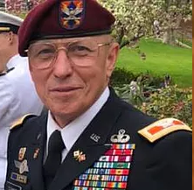
Chris (Moon) Mullins - (Secretary)
Rock Schmidt- (Vice Chair)
Steve Sargent (Treasurer)
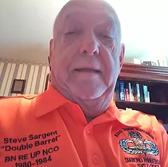
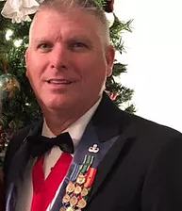
Chapter Committee Leads, Historian, Website, Facebook leads, and Trustees listed here

Upcoming Chapter Events

August 17 National Airborne Day and CMP Range Day, CMP Marksmanship Park, 1000;
September 21 Monthly Meeting/Social, 525 Riverwood Drive, Hokes Bluff, Alabama.

Upcoming National Events

October 10-13 All Ohio Airborne Days, Lockbourne, Ohio;
October 19-22 Hilton Head Weekend, Hilton Head, South Carolina.

Signal Soldiers doing great things for the Chapter and their community:

Theresa Dvorak- 1998-2001 HHC, and A. Company!

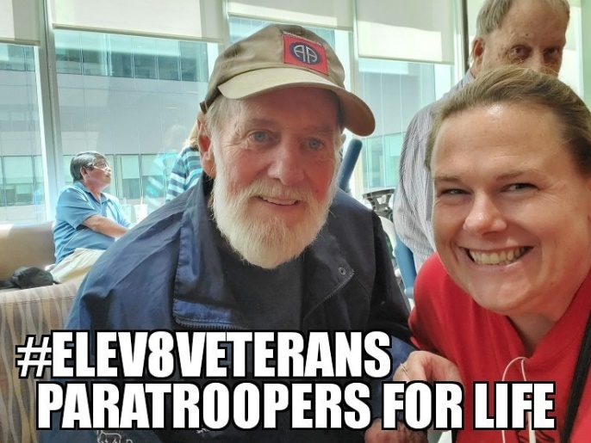
My Denver VA visit for the day. I found a Paratrooper! It isn't easy when we are elite. Room for more content here Theresa. Can you elaborate on what you do everytime you visit, who you look for?, how you meet them, etc…

Stephen Lee- 1998-2001 A. Co. Standard Node Platoon. A-Team Rocks Hard!

The GF and I drug a bunch of trash out of our local river yesterday, had to bring America’s Guard of Honor along! Feels good fighting a different kind of fight for the homeland!

It was not pretty or easy, but we chipped in our little bit, today! The French Broad River needs a lot of help, we ought to pick up after ourselves and set the right example! Super proud of Kristen Martin for being amazing and of what we accomplished.

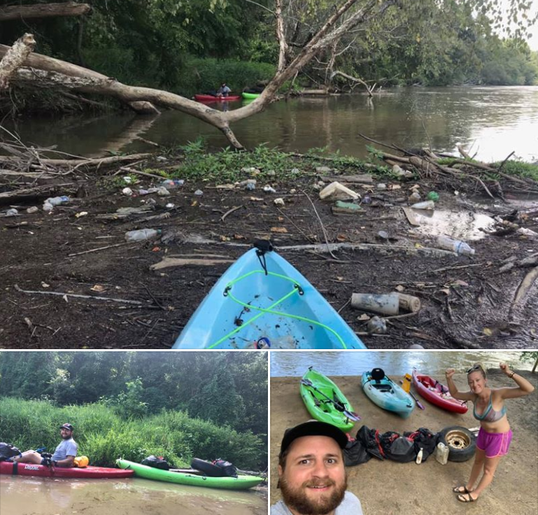

Fred (Chico) Santiago

Cee Freeman

Mark Tobert

Chris Pursel

Chaplain Smith

Signal Battalion History:

Platoon Highlight (Soldier Stories)

Command Highlight (Former Bn CDRs, Officers, CSMs, SGMs)

August Core meeting:

As more details become available for events they will be published in the newsletter. Registration forms are available at the Association website or from the Secretary.

Wreaths Across America The Chapter is participating in the Wreaths Across America fundraiser again this year. We would like to thank all of those that assisted last year and would like to see a bigger effort this year. We are looking for businesses to sponsor wreaths for the Sandhills Cemetery. A donation of $15.00 for each wreath sponsored is all that is required. We would like members to obtain sponsorships of at least ten wreaths for local businesses. Wreaths Across America is a 501(c)(3) organization so all donations are tax deductible. For each wreath sponsored the Chapter will receive a $5.00 donation from Wreaths Across America the following month. Remember, donations should be made in $15.00 increments, i.e. ten wreaths would be $150.00, fifteen wreaths would be $225.00, etc. and checks should be made out to Wreaths Across America and not to the Chapter. Please send all donations to the Chapter so we can keep track of the number of wreaths sponsored. Donations can also be made online through the Chapter page on their website. More details will be provided in future emails.

Membership: A number of you receiving the newsletter are not members of the Chapter, either having let your membership lapse or never having joined. I have kept you on the newsletter distribution list to keep you informed about the Chapter and to get you back into the Association. I would urge you to renew or obtain your membership in order to keep receiving the newsletter. The Chapter is now set up to do some good things in the next few years and you will want to be a part of that.

Chapter Website Please check out the Chapter’s website at www.airbornesignal.com and let one of the officers know what you think about it and any suggestions you have. We do try to post updates of information relevant to the Chapter in the news section. The most recent newsletters are contained on the website. If you go to the National website, which is linked from our page, you can find what upcoming events are scheduled, the latest bulletins and the Paraglide.

The Chapter also has a Facebook page. The page is open to anyone, not just Chapter members, to provide the widest exposure as possible. So be sure to check us out online. Under the events section on the page the date on location of all meetings are shown and the newsletters are posted under the documents section. So be sure to check us out online.

Room for God in our Chapter. Words from our Chaplain Mike Smith:

TAPS: On July 29th Spc. Michael Isaiah Nance of Chicago, Illinois and PFC Brandon Jay Kreischer of Stryker, Ohio were killed in a combat related incident in Afghanistan. Both were assigned to the 1st Battalion, 505th PIR, 3rd Airborne Brigade Combat Team of the 82nd Airborne Division. The Chapter wishes to express our condolences to the family of both Troopers and their comrades still deployed.

Chapter and 82nd Signal Battalion Pride: The Signal Chapter has the following items for sale to show your Association and Chapter pride. Most items are now being discounted by fifty percent. Please help support the Chapter by purchasing and wearing or displaying the Chapter’s name and logo. These items are available for viewing on our website at, https://www.airbornesignal.com/chapter-products

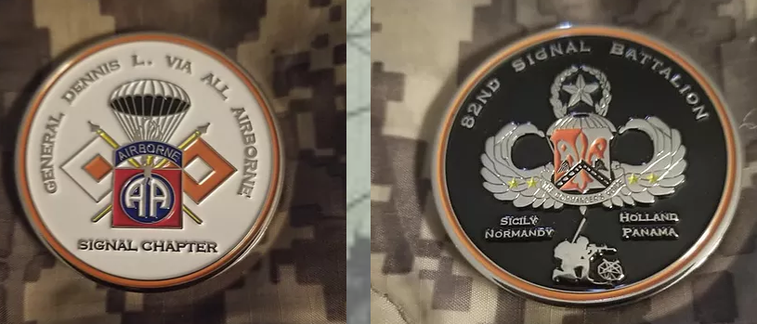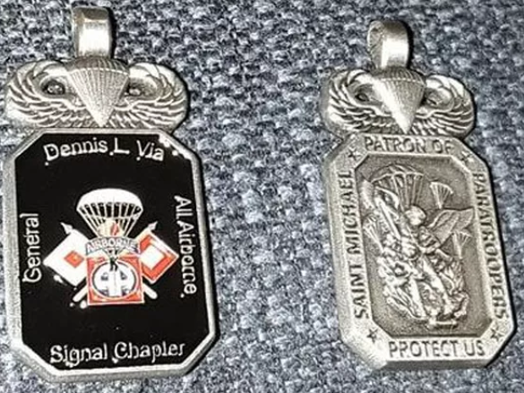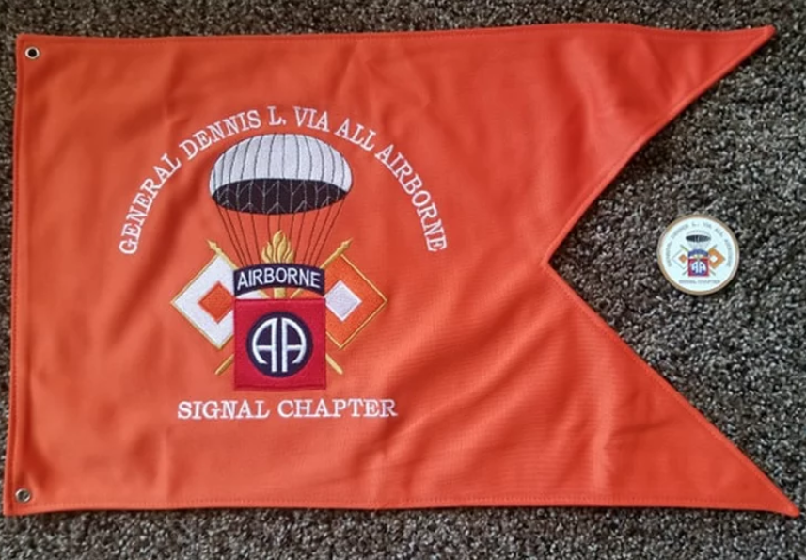

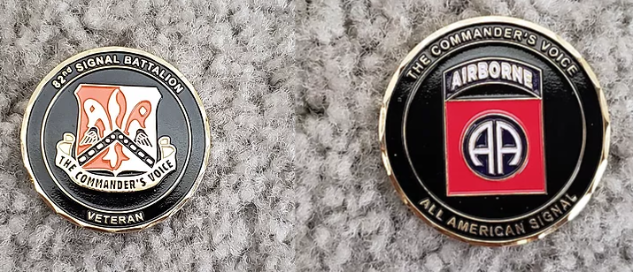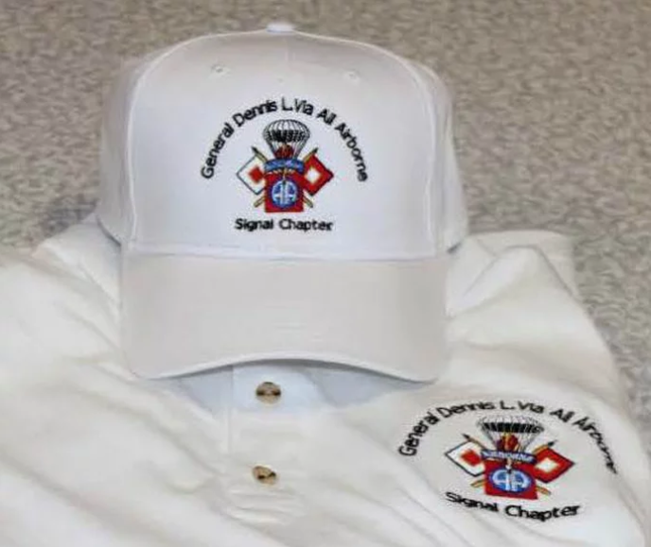

Chapter Coins (top left picture) $15.00
St. Michaels’ Medallion $15.00
Chapter Mini Flags $25.00
New Battalion Coins $10.00
Chapter Hat and Chapter Polo $50.00 package deal

All items are available for sale at chapter meetings and they can also be ordered by contacting Pete Hill at petehill1956B@gmail.com, on Facebook, or text to 610-389-1041. All prices include First Class mailing with tracking.

Monument: Fundraising is still proceeding on a monument for the 82nd Airborne Division on the Walk of Honor at the National Infantry Museum at Fort Benning. To view the proposed design and to donate please go to the website, http://www.82ndmonument.org/ If you have any questions or need more information you may contact Chris “Moon” Mullins the Chapter Secretary.

NOTICE: Neither the Signal Chapter nor the 82nd Airborne Division Association National headquarters sells or in any way releases the phone number, postal address or email address of members to outside organizations. All such information is used only to contact members regarding official Chapter or Association business.

Anniversaries: As mentioned previously, 2019 celebrates the 75th anniversary of several events involving the 82nd Airborne Division and other Airborne and Ranger units in World War II. January marked the 75thanniversary of the Anzio invasion which involved Darby’s Ranger force, the First Special Service Force, the 504th PIR and the 509th PIB; the June 6th D Day anniversary, which involved the 82nd and 101st Airborne Divisions and the 2nd and 5th Ranger Battalions, occurred last month; July marked the anniversary of the 503rd PRCT jump on Noemfoor Island in New Guinea; just prior to range day at the CMP the anniversary of Operation Dragoon, which involved the 1st Special Service Force, the 517th PRCT, the 509th and 551st PIBs, the 550th AIB and other smaller Airborne units, will occur; the Operation Market Garden anniversary, which involved the 82nd and 101st Airborne Divisions, is in September; The invasion of and capture of Leyte in the Philippines occurred in October of 1944 and lasted through December; and the anniversary of the Battle of the Bulge will be in December and involved all of the American Airborne and Ranger units in Europe at the end of 1944. This upcoming year let’s remember the courage and sacrifice of those Troopers who built a reputation for the Airborne still revered by our Country.

Association Online: The 82nd Airborne Division Association has set up a DZ online. First, the Association has a website that contains a variety of information and links, such as the monthly National bulletins. With the Convention about to kick off there probably will not be an August bulletin. The Summer issue of the Paraglide has been uploaded to the National website and is available for viewing. Special events for 2019 are included on the national website and you can download the registration forms and other documents that are linked to that event. To access the Association website, go to www.82ndAirborneAssociation.org

Also, the Association provides an electronic newsletter to members to keep everyone updated on the latest Army and Airborne related news. The newsletter is sent out every other week and contains links to informative articles on the Division, the Airborne community, Military and Veterans issues, and articles and information about the Association. The link to the National Bulletin is sent out in this newsletter prior to it being posted online. In order to sign up send National your email address so you can be added to the distribution list.

Signal Battalion History:

Signal Battalion History:

Signal Battalion History:

Signal Battalion History:

Signal Battalion History:

Signal Battalion History:

Signal Battalion History:

Signal Battalion History:

Signal Battalion History:

